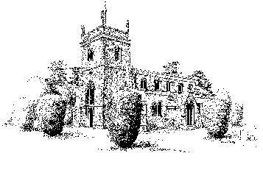
The Friends of St Lawrence Church Bovingdon
Registered Charity No. 1112950

Annual Report - 2018
Mission

The Friends of St. Lawrence Church Bovingdon (the Trust), often referred to as The Friends of St Lawrence Trust, exists in order to help ensure the preservation of Bovingdon’s Parish Church and Churchyard for current and future generations. The Trust is a registered charity which is independent from St Lawrence Church but works closely with it in order to fulfil its objectives.

The governing document for the Trust is the Trust Deed dated 5th October 2005.

Principal Office

Long Meadow, Flaunden Lane, Bovingdon, Hertfordshire, HP3 0PA

General

Phase II of the churchyard project is now complete and the final payment of £7,000.00 paid for the sculpture by Matthew Maddocks.

The next substantial project will be the redecoration of the interior of the church which will be a major undertaking.

Activities

During the year, Caroline Walker hosted a coffee morning and the second Music Festival raised £4,157.
Donations made to the PCC of St. Lawrence Church aggregated £3,496 of which £2,100 was in respect of the work done to trim fifty yew trees.
Donations received aggregating £7,165 were in line with last year.

Finance

We started the year with funds of £51,146.68 of which £8,120 was restricted for the churchyard project. We are carrying forward a balance of £53,836.30 of which £1,120.23 is restricted for churchyard maintenance. £48,836.30 is held at the discretion of the Trustees. Most of this money will be consumed by the redecoration of the interior of the church.

Accounts

The accounts are prepared on a receipts and payments basis.

Personnel

With great sadness we report the passing of Carl Perkins. Tom Morkill and Caroline Walker were appointed Trustees during the year. The other Trustees are Charles Burch, Pauline Wright, Jane Cayley and John Walker.

John Walker
Chairman and Treasurer

